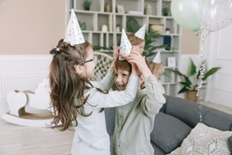
Keiki Birthday Week

Date: | 15th – 19th July

Duration: | Minimum one week, up to three weeks

What is the special event and why is it important to Keiki? | A focus of Keiki since 2003 has been on relationships and connections. Celebrations are an opportunity to create a sense of connection and belonging.  Celebrating meaningfully is a wonderful opportunity for children to learn about themselves and others (the beginning of their journey to learning empathy), share out core values with children, families and the community and provide unique experiences for children to be creative and show initiative.  It is also a great opportunity to have fun! The past three years have been challenging, celebrations have been harder to arrange and plan for. This year, we are celebrating a big year. Let’s celebrate in style, collaborating with children, families and the community.

What are our expectations?
  Date | Duty | Who | Completed
  27/5/24 | Print event sheet and display in staff room or staff area. Give Fact Sheet to Ed Leader to share with Rooms. | Coordinator
  3/6/24 | Print and hand out blank Keiki Reflection Tool for each room/age group to reflect on current children and educators within the service, the local community, and their connection to the event.  Store this in your evidence folder under QA1 | Coordinator
  3/6/24 | Send out surveys or use Mind Maps to gather family and children’s voices.  Gather the voices of the community (optional if relevant to your service and the event)  Store this in your evidence folder under QA1 | Ed Leaders  Coordinators
  17/6/24 | Gather reflection sheets and collate feedback and voices of children, families, and the community. | Coordinator
  17/6/24 | Plan events from the information gathered from families, children, educators and the children. | Coordinator, Room Leader, and Ed Leader
  24/6/24 | Send details to Marketing for posters and submit Budgetly request if needed | Ed Leader or Coordinator
  1/7/24 | Inform families on Xplor and via posters | Coordinator
  8/7/24 | Send reminder on Xplor (Hub message/Comms post) of anything that’s needed (i.e. dress up day) | Coordinator
  22/7/24 | Send photos to Marketing.  Complete critical reflection. | Coordinator  Educators and Ed Leader.

Activity Ideas | Involve the families, children, and all educators in planning this event. Learn how your community celebrates birthdays and other special events and use this information to create experiences and activities for children that build upon their interests and knowledge and help them feel a sense of belonging in the service.  - Put a mind map out for families, at least six weeks before, to ask families about how they celebrate birthdays.  - Use your time with children to ask them what birthdays and celebrations mean to them.  - Put a mind map out for educators in each room, the staff room or at a team meeting.  Ideally, plan a week-long celebration full of birthday activities and food, encouraging children across the services to get involved. For OSHC services that are celebrating during Vacation Care, one day is sufficient. Design the week of celebrations around the interests of children in your care; these should be special experiences the children wouldn’t normally get to do every day.  Families can be notified of the celebrations prior to our birthday week and any suitable images can be sent to marketing to post on Facebook.  - Cook party/celebration food that is specific to your children’s or educators’ culture or family traditions    - Sing songs that reflect the cultures within your service and how they celebrate birthdays (for example, Happy Birthday in other languages)  - Happy Birthday in Noongar  - Party-themed food (finger foods, healthy cakes etc)  - Party games such as musical statues or pass the parcel  - Music, dancing and face painting  - Bubble day  - Dress up days e.g. pyjama day/crazy hair day  - Teddy bears picnic  - Create birthday/gift cards or party decorations with the children  - Discuss birthdays and celebrations with the children, age appropriate. (Great way to discuss numeracy – sequencing and dates)  - Create musical instruments from natural resources to use while singing happy birthday  - Make a birthday cake out of playdough and natural resources  If there are any experiences you would like posted on social media, please send images and a description to marketing@keikiearlylearning.com.au  Inspiration from Keiki services in previous years (scan the QR code or click the link)   Keiki Birthday 2022  Keiki Birthday 2023

Resources | Key Word Sign   | Survey Question Suggestions  How does your family celebrate birthdays?  What foods do you eat during birthday celebrations?  What sort of clothing do you wear during birthday celebrations?  What sort of music do you listen to during birthday celebrations? | Spotify Playlist   | Mind Map Topics  How do you celebrate birthdays?

Keyword Signing | Happy Birthday Song  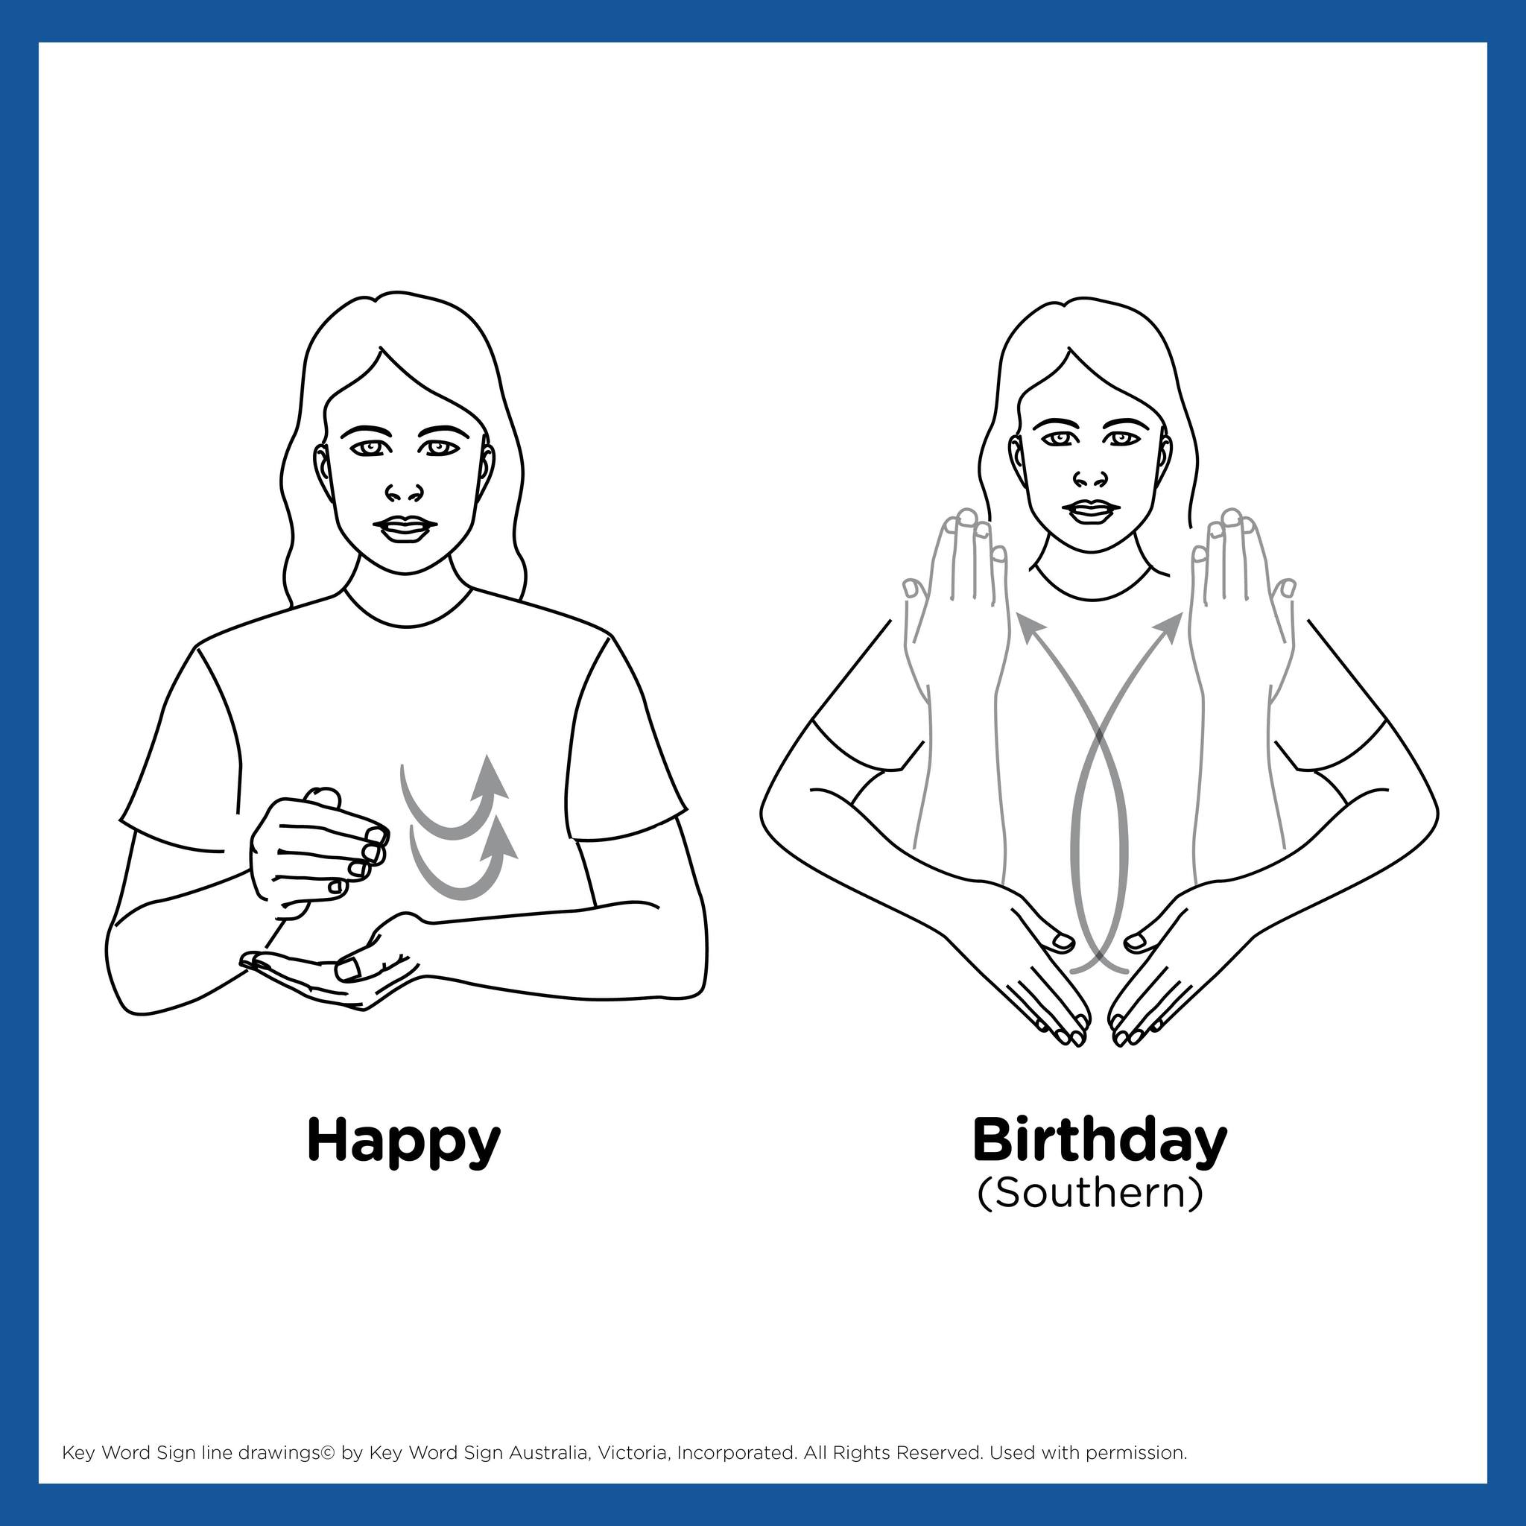

LINKING THIS EVENT TO RESOURCES AND DATA
To support educators, educational leaders and early childhood teachers we link each event with important and valuable resources that support and inform our decision making at Keiki.
How can we link this event to our Philosophy? | Core Value: Our Community  Our relationships with children and families are strengthened as we consistently explore and develop a deeper understanding of the diversity and culture of families and the broader community.  We respect and welcome all contributions from children, families and community members to our shared space of play and learning. By creating an inclusive environment our curriculum is enriched and each child’s sense of belonging and development is enhanced, helping to create a strong foundation for lifelong learning.  Core Value: The Whole Child  Our highly experienced teams provide beautiful, thoughtful environments where children are invited and encouraged to make their own choices, to explore the arts, enjoy physical play, practice mindfulness and develop meaningful, positive relationships with others.

How does this event link to the AEDC Data? | Physical Health and Wellbeing  Provide opportunities for children to enjoy physical activity experiences. Provide ‘good choice’ food at the party.  Social Competence  Set up experiences that provide children with the opportunity to work with and alongside their peers as well as share their ideas.  Emotional Maturity  Use stories, discuss feelings and other’s feelings. Talk about celebrations and how they feel to help them begin to recognise how others may feel.  Language and Cognitive Skills  Create opportunities for children to share their ideas and explore their ideas together.  Communication and General Knowledge  Talk to and listen to the children. Read stories and sing songs.
  Area | At Risk | Vulnerable
  Stirling | 8.9% | 8.4%
  Joondalup | 8.1% | 5.4%
  Wanneroo | 11.9% | 8.2%
  Area | At Risk | Vulnerable
  Stirling | 12.8% | 6%
  Joondalup | 9.6% | 4.4%
  Wanneroo | 13.5% | 7.5%
  Area | At Risk | Vulnerable
  Stirling | 13.3% | 6.7%
  Joondalup | 10.7% | 4.6%
  Wanneroo | 14.1% | 7.2%
  Area | At Risk | Vulnerable
  Stirling | 9.3% | 5.6%
  Joondalup | 6.9% | 3.1%
  Wanneroo | 11.8% | 6.6%
  Area | At Risk | Vulnerable
  Stirling | 11.4% | 6.8%
  Joondalup | 9.6% | 3.5%
  Wanneroo | 13.8% | 7.9%

How does this link to the ECA Code of Ethics? | In relation to children, I will:  - Act in the best interests of all children  - Create and maintain safe, healthy, inclusive environments that support children’s agency and enhance their learning  - Ensure childhood is a time for being in the here and now and not solely about preparation for the future

How does this event link to the UN Rights of the Child? | Articles:  Article 12: Children have the right to say what they think should happen when adults are making decisions that affect them and to have their opinions taken into account.  Article 29: Education should develop each child’s personality and talents to the full. It should encourage children to respect their parents, their culture and other cultures.  Article 30: Children have the right to learn and use the language and customs of their families, whether or not these are shared by the majority of the people in the country where they live, as long as this does not harm others.  Article 31- Children have the right to relax, play and to join in a wide range of leisure activities  Please talk to the children about the Rights of the Child. Do you have it displayed in your service for the children?

How does this event link to Aboriginal and Torres Strait Islander Culture? | Traditionally, birthdays (as an annual recognition of birth) were not celebrated; however today many Aboriginal people enjoy celebrating birthdays the same way as other Australians.  The traditions of the Noongar people are diverse and may vary, however, many Aboriginal people may use birthday celebrations as an opportunity to acknowledge significant life milestones, share traditional Noongar foods such as kangaroo, emu, and native plants and fruits, spend time connecting to Country through bush walks, fishing or camping or enjoying their rich cultural traditions of storytelling, dance, and music.

How does this event link to the National Quality Standards? | 1.1.2 Each child’s knowledge, strengths, ideas, culture, abilities and interests are the foundation of the program. – using input from children and their families in the planning for this event, you are meeting his benchmark.  1.2.1 Educators are deliberate, purposeful, and thoughtful in their decisions and actions.  6.1.2 The expertise, culture, values and beliefs of families are respected, and families share in decision-making about their child’s learning and wellbeing.

How does this event link to the Sustainable Development Goals? | Goal 4: Quality Education

